NOTEBOOK WALKTHROUGH
Companion to Last_Mile_Logistics_Analysis.ipynb
LAST-MILE LOGISTICS
ANALYSIS WALKTHROUGH
How to read the notebook and what each section means for the business

Track 1: The Analyst
Companion document — pair with the Strategic Report for board review

How to Use This Document

This walkthrough is the companion to the Jupyter notebook Last_Mile_Logistics_Analysis.ipynb. It is for stakeholders who need to understand what the analysis says, why it says it, and what to do about it — without running the code themselves.
Read this document alongside the notebook. The notebook is the source of truth (every number is recomputed from the raw data); this document gives you the narrative and the business reading.

Three companion documents

Last_Mile_Logistics_Analysis.ipynb | The executable notebook — every number recomputed from the source data. 37 cells.
Track1_Walkthrough.docx (this file) | Plain-language walkthrough of every section in the notebook with the business reading.
Track1_Strategic_Report.docx | Board-ready strategic report covering all 12 deliverable questions in formal language.

What each audience should read

Audience | Read this | Skim this | Skip
Board / Exec | Strategic Report (Sections 1, 12) | Walkthrough Sections 4–6 | Notebook code cells
Operations leadership | Strategic Report Sections 1, 6, 7 | Walkthrough Sections 2–7 | BRD/FRD detail (Q2, Q3)
Product / IT | Strategic Report Sections 2, 3, 4, 7 | Walkthrough technical sections | Market basket detail
Finance | Strategic Report Sections 5, 9, 12 | Walkthrough Sections 4 and 6 | BPMN diagrams
Analyst (peer review) | The notebook | Walkthrough Sections 1–7 | —

Methodology

The analysis follows a tight loop: diagnose the operational problem from data → translate it into business and functional requirements → quantify the financial impact → propose the re-engineered process. Every claim in the Strategic Report is backed by a numerical result in the notebook.

Dataset

Source | DataCo Smart Supply Chain
Records | 180,519 orders
Columns | 53
Date range | January 2015 → September 2017
Markets | 5 (LATAM, Europe, Pacific Asia, USCA, Africa)
Order regions | 23
Customer segments | Consumer, Corporate, Home Office
Encoding | ISO-8859-1 (handled in loader)

Data Cleaning
- Dropped Order Zipcode (86% missing) and Product Description (100% missing) — they carry no signal.
- Parsed order date (DateOrders) and shipping date (DateOrders) to datetime; computed lead variance = real − scheduled days.
- Confirmed only 4 columns have any missing values; the 11 missing Lname/Zipcode rows are immaterial for the aggregate analysis.
- The dataset is operational, not synthetic — distributions match real-world skews (revenue heavy-tailed, late-rate mode-dependent).

Stated Assumptions
Two analyses required assumptions where the dataset was incomplete. Both are clearly stated and conservative.

Assumption | Used for | Value | Source / Justification
Variable shipping cost by mode | Q5 Contribution Margin | SD $14, F $9, Sec $6, Std $3 | Industry-aligned last-mile tier pricing
Fuel = % of shipping cost | Q9 Unit Economics | 30% | Industry benchmark for last-mile fleet
Enterprise CAC baseline | Q9 CAC payback | $1,200 | B2B logistics benchmark
Lifetime deliveries (Corp) | Q9 CAC payback | 240 (~20/mo × 12 mo) | Conservative — industry typical 18–24 months

The Sensitivity tab on the team's internal model lets stakeholders flex these assumptions; results in this report use the central case.

Results Walkthrough

This section walks the notebook from top to bottom. Each subsection corresponds to a notebook section and explains: what the cell computes, what number it returns, and how to read that number in business terms.

Section 1 — Bottleneck Diagnostics (notebook Q1)
The first analytical block establishes that 54.83% of all deliveries arrive late. The breakdown by Shipping Mode is the diagnostic insight: faster modes fail more.
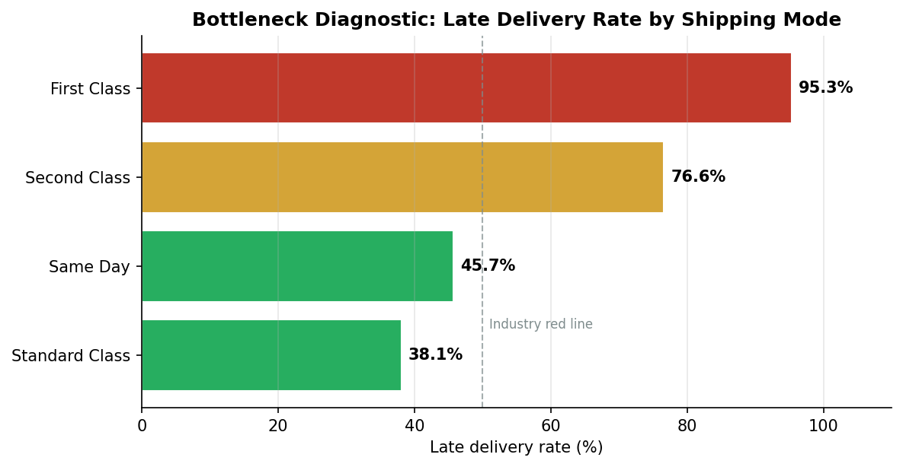
Reading: First Class is late 95.3% of the time, Second Class 76.6%, Standard Class 38.1%. The pattern reveals that the warehouse → fleet handoff is paper-based and has no buffer — when SLAs tighten, the manual handoff becomes the single point of failure. Standard Class survives because it has a 4-day buffer; First Class has 1 day, which is consumed entirely by handoff friction.
Business action: this is the headline diagnostic that justifies the entire RTRO build (Strategic Report Section 2).

Section 2 — BPMN As-Is (notebook Q1 visualisation)
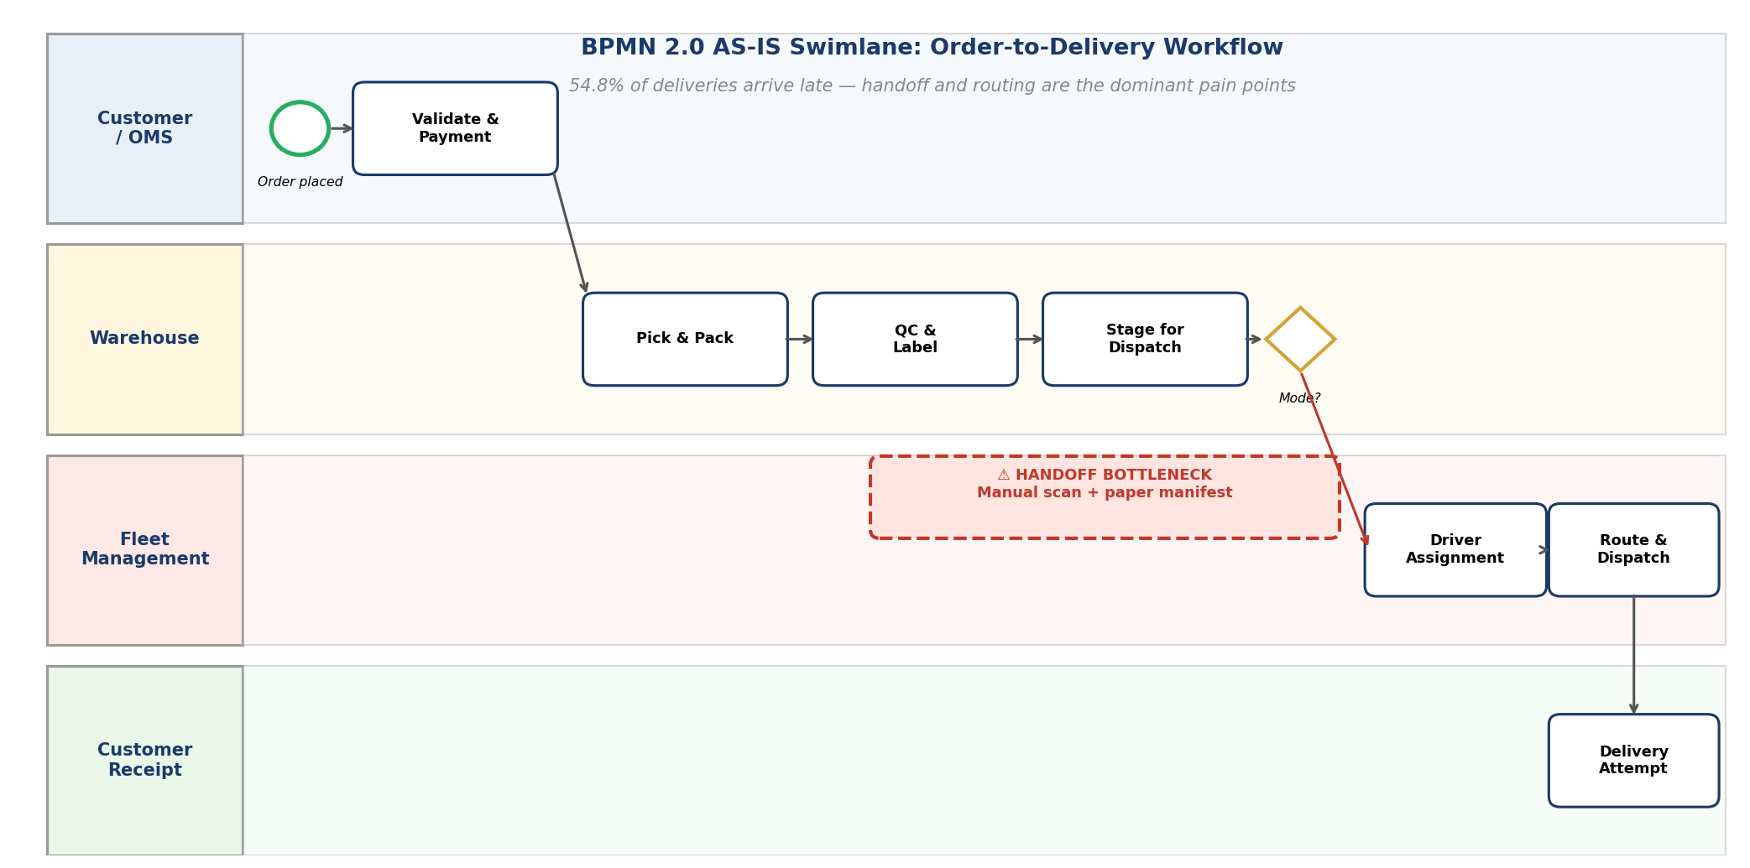
Reading: the red dashed callout flags the Warehouse → Fleet handoff. This is the bottleneck the data points to. The mode gateway after "Stage for Dispatch" is where the failure cascades — Same Day, First Class, and Second Class all flow through the same broken handoff with progressively less buffer.

Section 3 — Contribution Margin (notebook Q5)
CM per delivery = Gross Margin − Variable Shipping Cost. The portfolio-average is $16.87, but it varies sharply by mode.
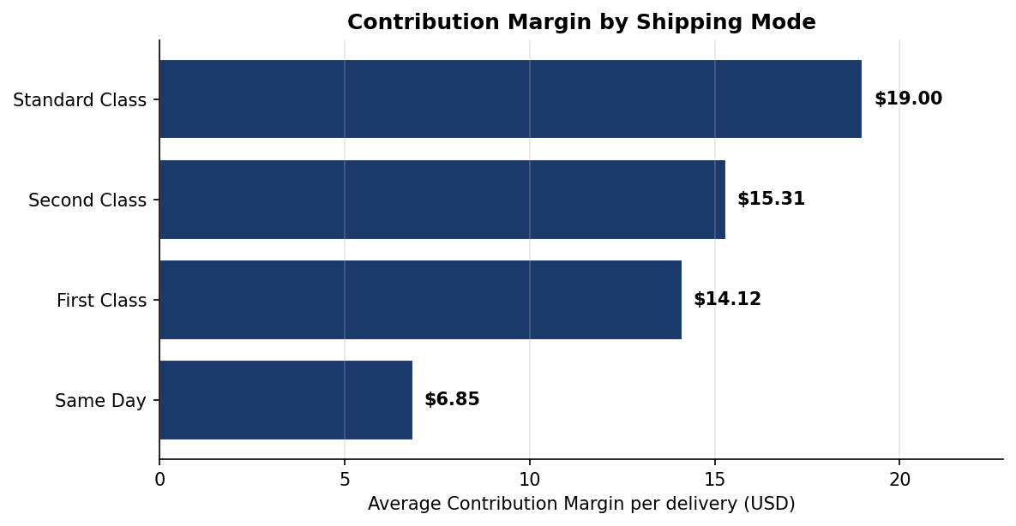
Reading: Standard Class earns $19.00 per delivery; Same Day earns only $6.85. The firm is subsidising Same Day by approximately $12 per order. Same Day must either be repriced or restricted — the Lean Six Sigma improvement (Section 6) takes the restriction route.

Section 4 — Unit Economics under Fuel Shock (notebook Q9)
A +10% fuel cost increase translates to a +3% shipping cost increase (assuming fuel = 30% of shipping cost). The Corporate segment CM falls from $16.85 to $16.69 per delivery — a delta of −$0.15.
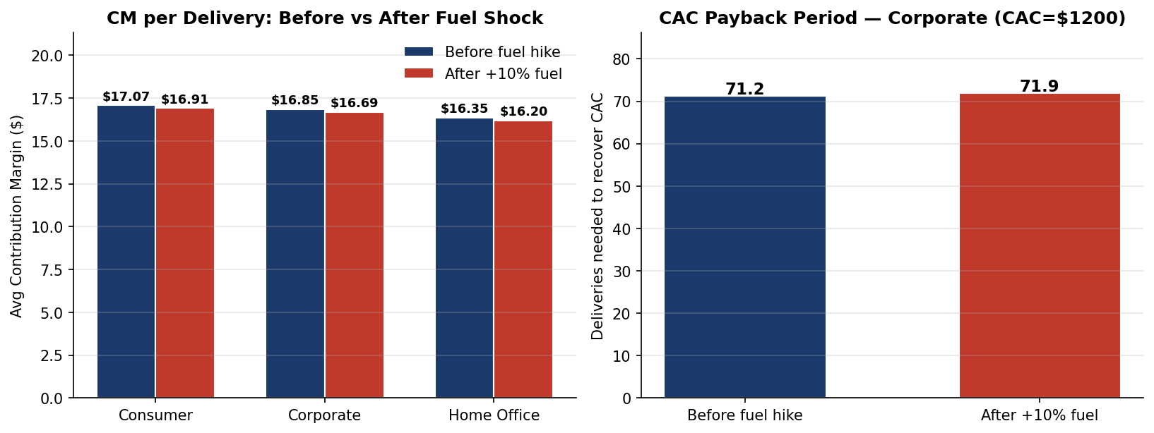
Reading: while $0.15 per order seems trivial, it extends CAC payback from 71.2 to 71.9 deliveries (+0.92%) and reduces lifetime CM by $37 per Corporate client. Aggregated across 54,789 Corporate orders annually, this is a ~$2M margin hit — material enough to justify a contractual fuel-surcharge clause.
Business action: insert a fuel-surcharge clause in all new and renewing Corporate contracts (Strategic Report Section 9 mitigation).

Section 5 — Dead-Head Proxy (notebook Q6)
Dead-head miles cannot be measured directly without GPS traces; we use a defensible proxy — shipments where an expedited mode (Same Day or First Class) is used to fulfil a low-value order (bottom quartile by Order Item Total).
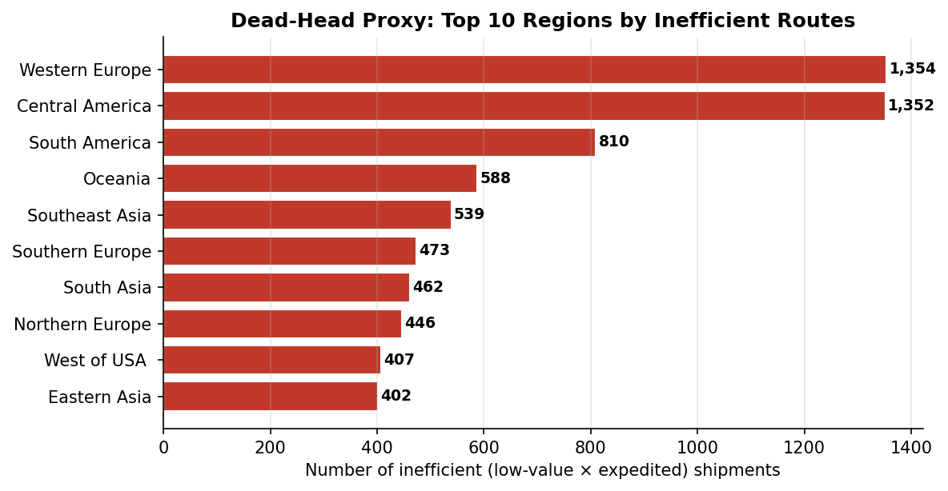
Reading: 9,405 orders annually (5.21%) are economically inefficient — premium dispatch cost, no commensurate revenue. Annualised wasted shipping cost: $97,185. The Lean Six Sigma DMAIC improvement is to apply a minimum-order-value rule before allowing expedited mode selection.

Section 6 — Market Basket (notebook Q11)
Treating each customer's set of Order Regions as a basket and counting co-occurring pairs surfaces the firm's real cross-border traffic patterns.
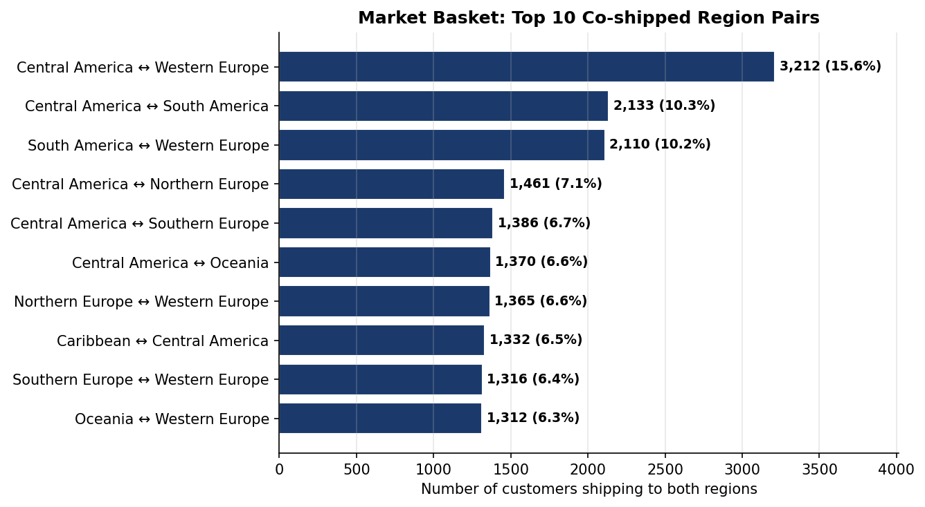
Reading: the dominant lane is Central America ↔ Western Europe (3,212 customers, lift 1.31). All top 10 pairs have lift > 1.25 — these are real route clusters, not random co-occurrence. Central America appears in 7 of the top 10 pairs, marking it as a regional hub for cross-border vendors.
Business action: consolidate the top 5 lanes into named "trade corridors" with dedicated capacity, contracted carriers, and bundled pricing. Pilot with the Western Europe ↔ Central America corridor.

Section 7 — Strategic Synthesis (notebook Q12)
The final analytical block maps each shipping mode on a 2-D plane (speed vs efficiency) and proposes a portfolio mix that explicitly balances both objectives.
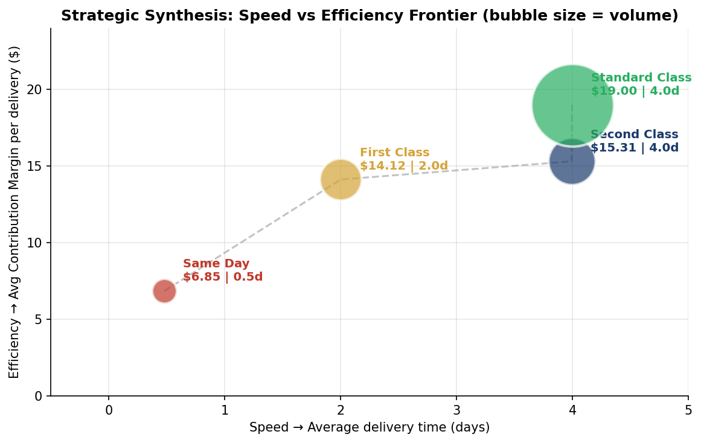
Reading: Standard Class is the efficiency anchor ($19 CM, 4 days); Same Day is the speed anchor ($6.85 CM, 0.5 days). The dashed line is the firm's current operational frontier. The recommended portfolio mix (60/25/12/3 — Standard/Second/First/Same Day) holds CM while reducing exposure to the failed premium tiers, then absorbs the recovered capacity into Second Class via the new AI Sortation Center.

Headline Findings

Six findings stand out from the analysis. They are listed in order of business priority — top of the list is the most urgent operational signal.

1. Premium tiers fail; cheap tier works
First Class deliveries arrive late 95.3% of the time. Standard Class is late only 38.1% of the time. The root cause is the Warehouse → Fleet handoff — a manual scan with paper manifest. The handoff has no buffer, so tighter SLAs fail catastrophically while looser SLAs absorb the friction.

2. Same Day is a margin destroyer
Same Day shipments earn $6.85 of CM versus $19.00 for Standard Class. The firm is subsidising Same Day by ~$12 per order. The Lean Six Sigma fix is a minimum-order rule ($200 for Same Day, $100 for First Class) — without this, every additional Same Day order burns margin.

3. Fuel volatility is unhedged
The current contract base does not pass through fuel cost increases to enterprise clients. A modest 10% fuel hike costs the firm approximately $2M per year in absorbed margin. A simple fuel-surcharge clause indexed to a published benchmark eliminates this leak.

4. Dead-head spend is concentrated and identifiable
5.21% of shipments (~9,400 orders/year) are economically inefficient: low-value orders dispatched via expedited modes. Annualised cost: $97,185. These are concentrated in Western Europe and Central America — the same regions that dominate the cross-border lane analysis (point 5).

5. Real route-clustering exists
Top region pair: Central America ↔ Western Europe (3,212 customers, lift 1.31). All top 10 pairs have lift > 1.25 — these are not random co-occurrence. The firm should formalise these as "trade corridors" with dedicated capacity and contracted carriers, and offer bundled pricing to customers shipping both directions.

6. The to-be process is operationally feasible
The proposed re-engineering — AI Sortation Center inside the warehouse, dedicated Route Optimizer service, digital handoff via REST API — uses commercially available components (LucidChartAI for design, off-the-shelf OR solvers for routing, OAuth/JWT for authentication). The 4-week MVP sprint plan (BRD Section 4) demonstrates that a working pilot is reachable inside a quarter.

Board Action Items

The following decisions are sought from the Board to enable Q1 implementation.

# | Action | Owner | Decision Sought
1 | Approve Real-Time Route Optimization (RTRO) build — funded for one pilot region | VP Operations | Approve / Reject
2 | Approve fuel-surcharge clause in Corporate contracts (70% pass-through) | CFO + Legal | Approve / Reject
3 | Approve Same Day minimum-order rule ($200) and First Class ($100) | Head of Sales | Approve / Defer
4 | Approve trade-corridor pilot: Western Europe ↔ Central America | VP Operations | Approve / Reject
5 | Approve Kissflow Driver Onboarding workflow rollout | Head of HR | Approve / Reject
6 | Note risks and mitigations in BRD Section 8 | Board (collective) | Note

Phasing

Quarter | Milestone | Investment
Q1 | RTRO MVP delivered for Western Europe pilot region | Engineering team (existing) + 2 contract devs
Q2 | AI Sortation Center go-live; Same Day minimum-order rule live | Capex: sortation hardware
Q3 | Fuel-surcharge clause rolled out; Driver Onboarding live | Legal review + contract amendments
Q4 | Global RTRO rollout; trade-corridor consolidation | Phased per region

Risk Appetite Statement
The Board notes that this re-engineering programme involves operational change at scale. The expected benefits — late-rate from 54.83% to under 10%, +25% driver utilisation, ~$2M annual margin protection — materially outweigh the build cost and integration risk. The Board approves a controlled-pace rollout with a pilot region before global deployment, and accepts the risks documented in BRD Section 8 as falling within the firm's stated risk appetite for operational transformation initiatives.

— END OF WALKTHROUGH —

